NCSC UK Compliance for Log360
Protect critical infrastructure and meet NCSC UK compliance with Log360.
Region: UK | Type: Critical Infrastructure, Incident Management | Category: Compliance | Pricing: Free

Overview
The NCSC UK compliance extension in Log360 helps organizations meet the NCSC Cyber Assessment Framework (CAF 4.0), the UK National Cyber Security Centre's framework for assessing cybersecurity of essential services across 4 objectives and 14 principles used by UK regulators via GovAssure by providing centralized log management, real-time security monitoring, and automated audit reporting. The platform supports NCSC UK requirements for governance, risk management, asset management, supply chain oversight, identity and access control, data security, system protection, security monitoring, and incident response.
For Governance and Risk Management, Log360 delivers centralized visibility across all log sources, enabling security teams to evidence governance controls and track risk posture through audit reporting. To address Asset and Supply Chain Management, the platform monitors software updates, registry modifications, configuration changes, and program inventory to maintain asset integrity and detect unauthorized supply chain activity. The extension also supports Identity and Access Control by providing capabilities that tracks AD logon events, Windows and Unix authentication, SUDO commands, failed logons, and user account changes to enforce access accountability.

Key Features
- Data Security: Log360 monitors file changes, SharePoint and OneDrive activities, S3 operations, and USB storage events to protect data assets across hybrid environments.
- System and Network Protection: Log360 tracks network device configuration changes, firewall rule updates, policy modifications, and network attack events to enforce system and network security boundaries.
- Security Monitoring and Threat Hunting: Log360 aggregates antivirus, threat detection, FireEye, Trend Micro, and network attack reports to provide real-time alerting and threat intelligence.
- Incident Response and Recovery Planning: Log360 monitors backup and disaster recovery operations, system events, and Windows restore activities to support rapid incident response and evidence collection.
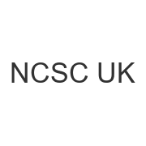
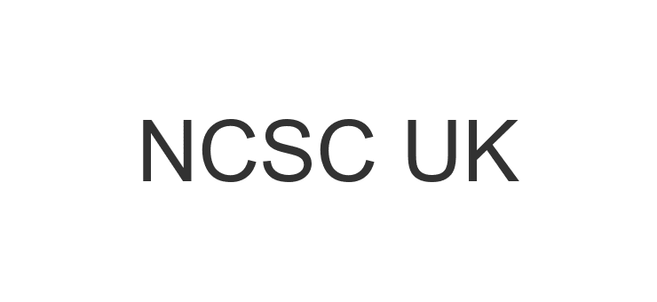
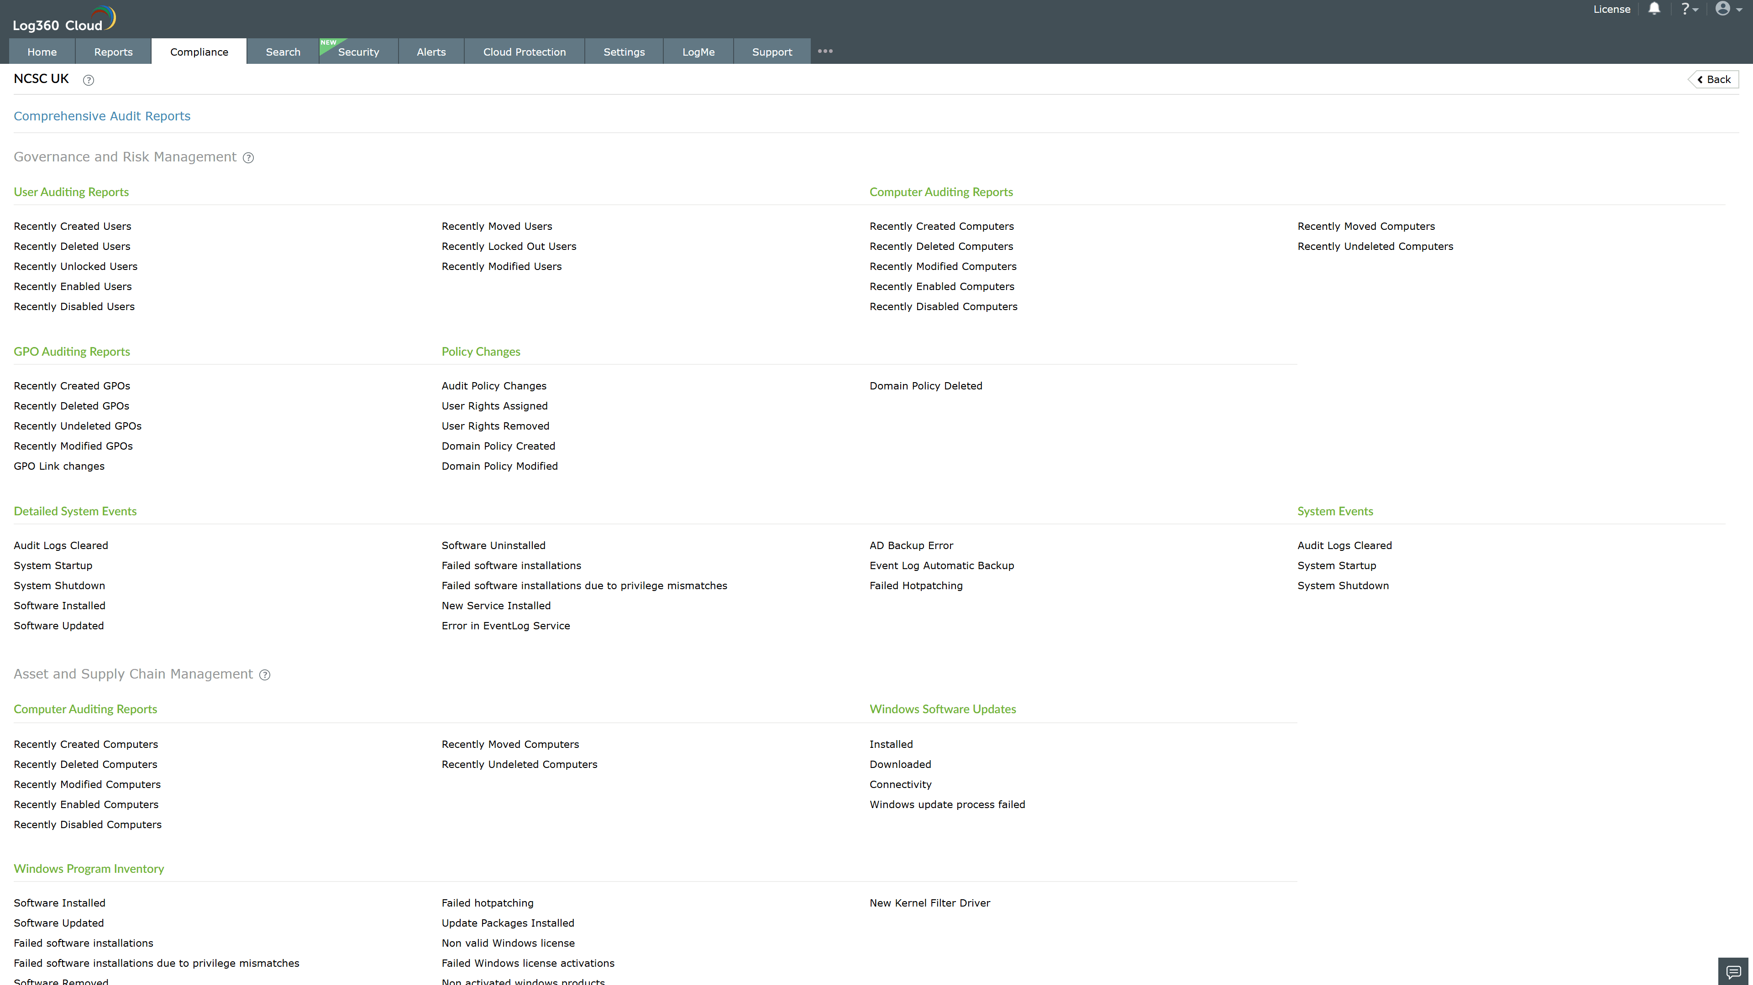
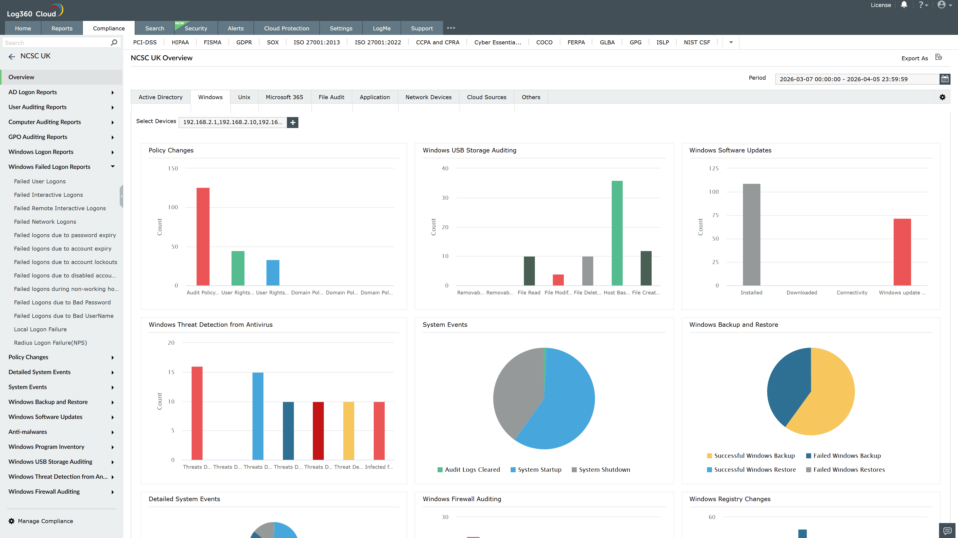
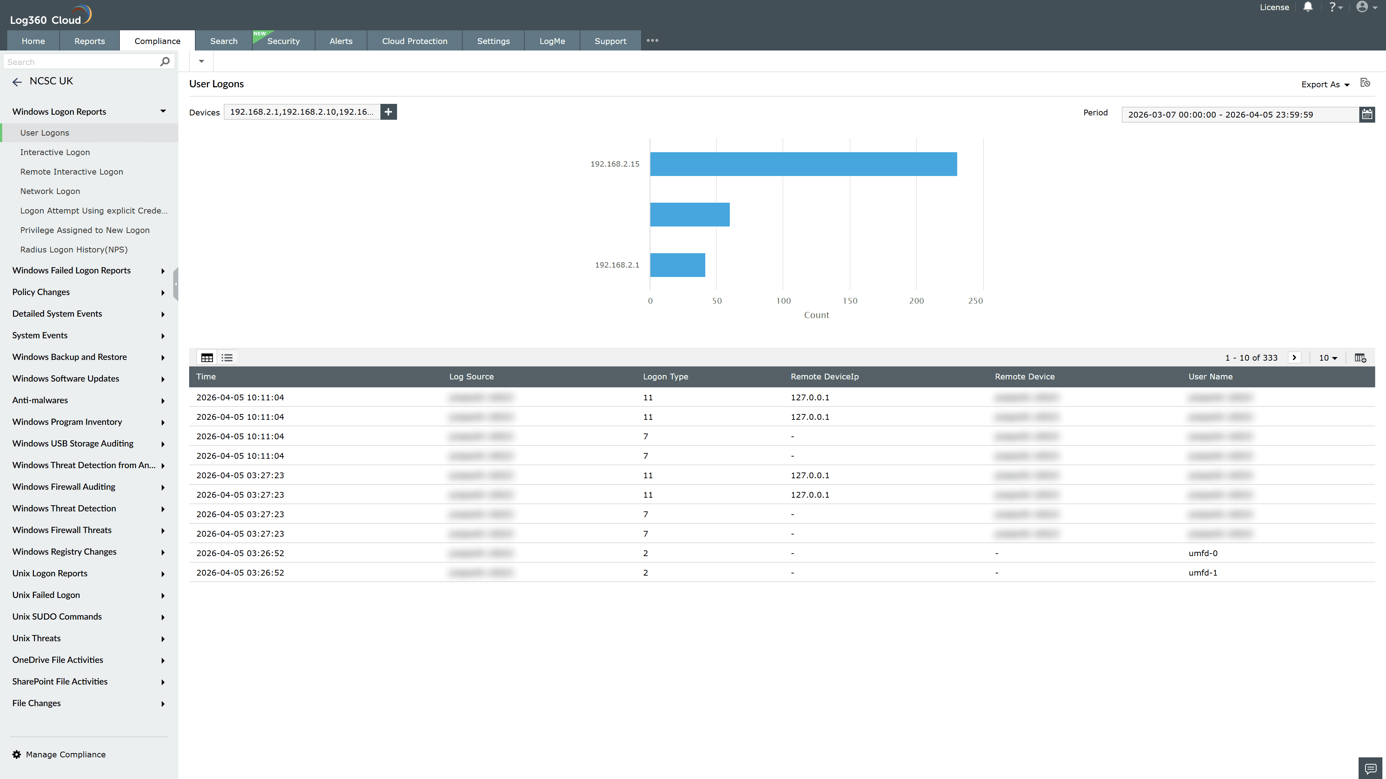
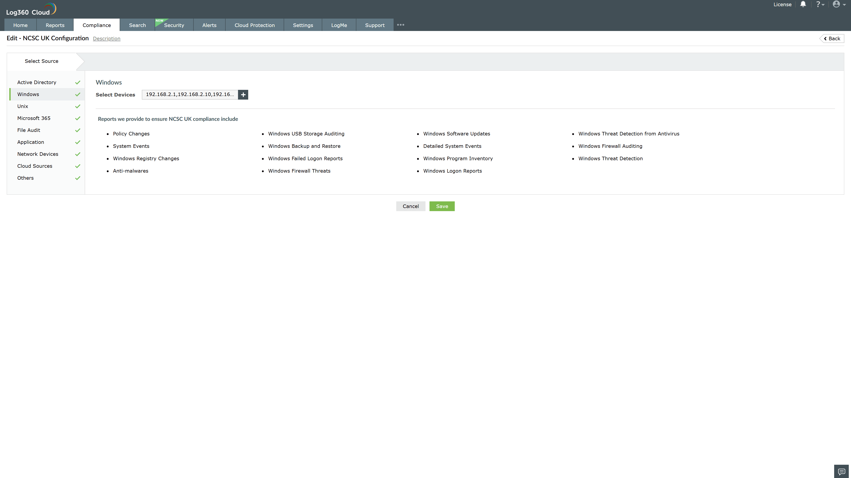
Valid Submission : Yes
Supported Editions : Free, Basic, Standard, Professional, MSSP
Help Document : https://www.manageengine.com/log-management/help/integrations/compliance-extensions.html
Help Video : Not provided
Tags : Log360, Compliance, Privacy monitoring, Data privacy, Regulatory compliance
Supported DCs : US, IN, JP, CA, AU, UK and EU
Privacy Policy:
Terms of Service:
Release Notes:
Predefined reports for the NCSC UK.

